33.61: a) Multiplying Eq. (1) by sin and Eq. (2) by sin yields:
(1):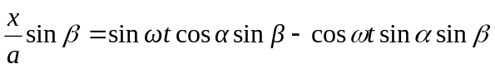
(2):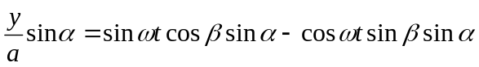
Subtracting yields: 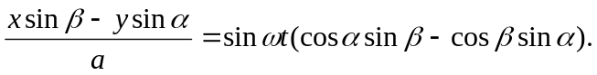
b) Multiplying Eq. (1) by cos and Eq. (2) by cos yields:
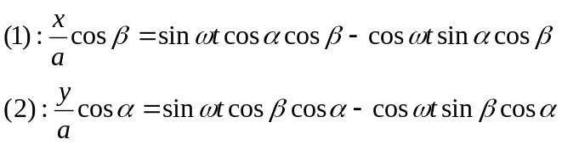
Subtracting yields: 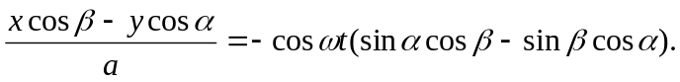
(c) Squaring and adding the results of parts (a) and (b) yields:
(d) Expanding the left-hand side, we have:
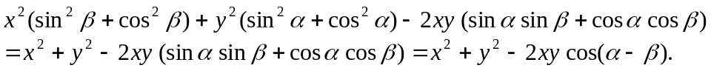
The right-hand side can be rewritten:
Therefore:
Or:
(e) which is a straight diagonal line.
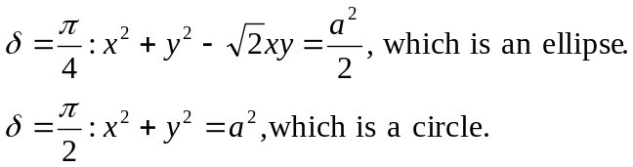
This pattern repeats for the remaining phase differences.

